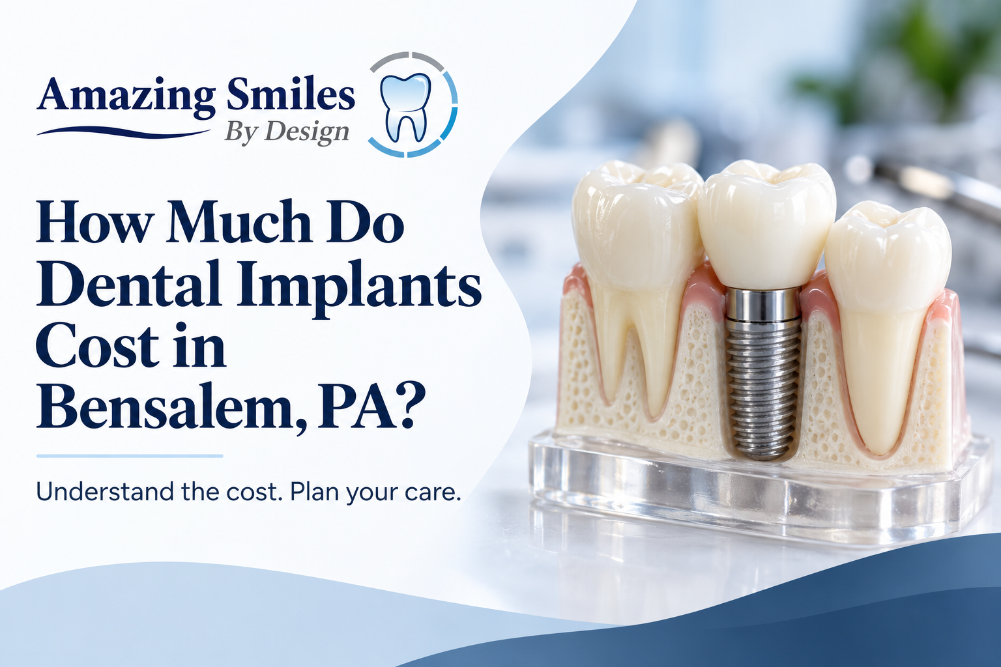
How Much Do Dental Implants Cost in Bensalem, PA?
Dr. Keyur Dudhat, DMD, Amazing Smiles By Design · Published 6 October 2026 · Updated 6 October 2026
QUICK ANSWER
A single dental implant in the US typically costs about $3,000 to $5,600, including the implant post, the abutment and the crown. Full-arch options cost more. Your exact price depends on how many teeth you are replacing, whether you need a bone graft, and the materials used. At Amazing Smiles By Design in Bensalem, you get a written quote at your consultation, not a guess online.

Key Takeaways
- A single implant usually runs about $3,000 to $5,600 in the US, covering the post, abutment and crown.
- Full-arch options like All-on-4 cost far more, often $11,600 to $27,500 per arch.
- The biggest price factors are how many teeth you replace, bone grafting and the materials used.
- Most dental insurance pays only part of an implant and caps what it pays each year.
- Our membership plan's 20% discount does not apply to implants, but CareCredit and Cherry spread the cost into monthly payments.

How Much Do Dental Implants Cost?
In the US, a single dental implant typically costs about $3,000 to $5,600, and larger cases cost more. That single-tooth figure usually covers three parts: the titanium post that replaces the root, the abutment that connects to it, and the crown on top. Here is how the common options compare.
Implant option | Typical US cost | What it replaces
Single implant (post, abutment, crown) | $3,000–$5,600 | One missing tooth
Implant-supported bridge | $4,000–$16,000 | Several teeth in a row
All-on-4 / full arch | $11,600–$27,500 per arch | A full upper or lower set
Full mouth (both arches) | $38,600–$90,000 | A complete set of teeth

These are typical national ranges from NewMouth's 2026 implant cost guide, not a quote for your mouth. What you actually pay in Bensalem depends on your case, which is why we give a written figure after an exam, never over the phone.

What's Included in the Price of an Implant?
A single-tooth implant price usually covers the post, the abutment and the crown, plus the surgery to place it. What is often quoted separately:
- The consultation and 3D imaging (we use a CBCT scan when it is needed for planning)
- A tooth extraction, if the old tooth is still there
- A bone graft, if there isn't enough bone to hold the implant
- Sedation — ask us about dental sedation options
When you compare quotes, check whether each one includes these steps or lists them on top. A low headline price often leaves them out.

What Makes Implant Costs Go Up or Down?
Several things move the price, and most come down to your specific mouth:
- How many teeth you are replacing, and whether it's single implants or a full arch
- Bone grafting, if the bone needs building up first
- Materials, such as the type of post and the crown
- Sedation — ask us about dental sedation options
- Extra steps like extractions before the implant goes in
At your consultation, Dr. Keyur Dudhat, who focuses on implant and cosmetic dentistry, checks your gums, bone and bite and explains exactly which of these apply to you, so the quote makes sense.

Does Dental Insurance Cover Implants?
Sometimes, but usually only in part. Many dental plans that cover major restorative work pay a share of an implant, often up to half of the covered portion. But they cap what they pay each year, commonly around $1,000 to $2,500.
Because implant treatment can run across more than one plan year, you can sometimes use two years of benefits. We accept PPO insurance, and coverage depends on your plan. We'll check your benefits with you and put what's left to pay in writing.
See insurance and payment options.

How Can I Pay for Implants in Bensalem?
Most people pay for implants with a mix of insurance and financing. Here's what you can use:
- Financing: CareCredit and Cherry let you spread the cost into monthly payments. See financing options.
- Insurance: we'll apply whatever your PPO plan covers.
- Honest note on the membership plan: our membership plan gives 20% off many treatments, but it specifically excludes dental implants. So for implants, financing and insurance are the levers, not the membership discount. We'd rather tell you that now than surprise you later.
If a full implant isn't the right fit for your budget, we'll talk through alternatives like a dental bridge or implant-supported dentures, and what each would cost in your case.
Ready for a figure on your own case? A consultation is the only way to get a real one.
▸ Book an Implant Consultation (/patient-information/scheduling/)
Or call or text (215) 639-5331. No pressure: if a bridge or denture would suit you better, we'll tell you.

Are Cheap Dental Implants a Good Idea?
Be careful with prices that look far below the ranges above. A very low quote often leaves out the abutment, the crown, imaging, grafting or follow-up, so the real total climbs later. Implants done in a hurry or with thin planning can also fail, which costs more to fix than doing it once, well. That doesn't mean paying the most; it means comparing like for like and asking what's included. A fair quote is clear about every part.

Questions to Ask Before You Pay for Implants
Bring this list to any implant consultation, with us or anywhere else:
- Does the price include the post, the abutment and the crown?
- Are imaging, extractions, grafting and sedation included, or added on?
- What material is the post and the crown?
- How many visits, and over how long?
- What happens, and what does it cost, if the implant doesn't take?
- What will my insurance cover, and what's my share in writing?
A practice that answers these plainly is one you can trust with the work.
IMAGE PLACEHOLDER — leave blank; practice-supplied photo.
Developer / designer: optional in-body image slot, left blank for a practice-supplied photo (the office, the CBCT scanner, or Dr. Dudhat). No stock or AI imagery. WebP, lazy-loaded, width/height set.

Getting a Straight Quote at Amazing Smiles By Design
The honest answer to "how much will my implant cost?" is that it depends on your mouth, and you deserve a real figure rather than a range off the internet. At Amazing Smiles By Design in Bensalem, Dr. Dudhat will examine you, plan the case with imaging when it's needed, and give you a written quote with your insurance and financing worked out.
▸ Book an Implant Consultation (/patient-information/scheduling/)
▸ Call or Text (215) 639-5331 (tel:+12156395331)
No pressure: if a bridge or denture would suit you better, we'll tell you.

Dental Implant Cost FAQs

How much is a single dental implant?
A single dental implant in the US typically costs about $3,000 to $5,600, which usually includes the implant post, the abutment and the crown. Your exact price depends on your bone, the materials and whether you need an extraction or graft first, so the figure is confirmed in writing after an exam.

Why are dental implants expensive?
Implants cost more than a filling because they replace the whole tooth, root and all, with a titanium post, a custom abutment and a crown, placed with surgery and 3D planning. The price reflects the materials, the lab work and the skill involved, and a well-placed implant can last for decades.

Does insurance cover dental implants?
Often only partly. Many PPO plans pay a share of the covered portion, up to an annual cap that is commonly around $1,000 to $2,500, so a lot of the cost is usually out of pocket. We accept PPO insurance, check your benefits with you, and put your remaining share in writing.

Are cheap dental implants safe?
A low price is not automatically unsafe, but a very cheap quote often leaves out the crown, abutment, imaging or grafting, so the real total is higher than it looks. Ask exactly what is included and what happens if the implant fails, and compare quotes on the same basis.

Can I pay for dental implants monthly?
Yes. At Amazing Smiles By Design you can spread the cost through CareCredit or Cherry financing, alongside whatever your insurance covers. Our membership plan's 20% discount does not apply to implants, so financing is the main way to make the payments manageable.

Book Your Implant Consultation in Bensalem
Get a real, written quote for your own case, with insurance and financing worked out. Call or text (215) 639-5331, or book with Dr. Dudhat at Amazing Smiles By Design, 3101 Bristol Road, Suite 1, Bensalem, PA 19020.
▸ Book an Implant Consultation (/patient-information/scheduling/)
▸ Call or Text (215) 639-5331 (tel:+12156395331)

For the editor
SEO title: How Much Do Dental Implants Cost in Bensalem, PA? (49 chars)
Meta description: What dental implants cost near Bensalem, PA, what changes the price, and how to pay with financing. Get a written quote from Dr. Dudhat. (136 chars)

Cover image brief (generate in GPT / your image tool)
- A reassuring Bensalem dentist discussing a treatment plan with a patient at a screen showing a dental scan, bright modern office
- A single dental implant model (post, abutment, crown) on a clean neutral background
- A patient smiling confidently after implant treatment, natural light
Export the final banner as WebP, 1600×600, and give it descriptive alt text when you place it.

